

**In Partial Fulfillment of the Requirement for the subject   
IT 332 - IT ELECTIVE 2**

**Presented to:**

Prof. Messica P. San Gabriel

**Presented by:**

Estrada, Jasper Sarah

Sabido, Ariel

Teleron, Brent Jake

**Date:**

January 2019

**HealthScan: Disease Scanning System**

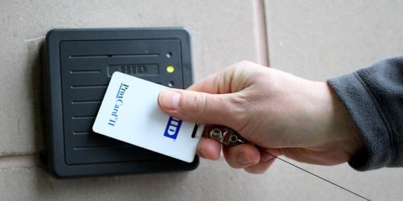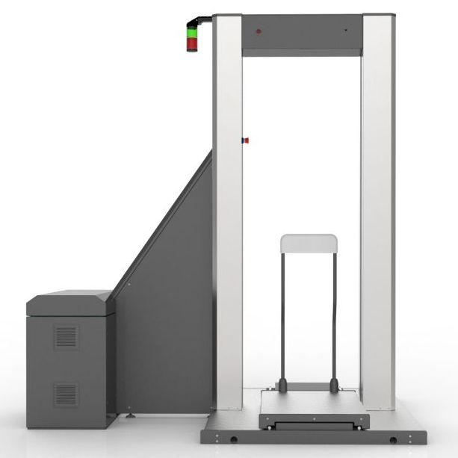

**INTRO** Health is important to each and everyone one of us. Everyone needs to be healthy and not only physically but also mentally and psychologically.

HealthScan is the Philippine’s first easy-to-use and easy-to-track scanning system that would ease the diagnosis of diseases, it uses a body scanner to take several scans of a user and analyzes these scans in real time to notify the user of their health through a notification on their emails or their smartphones, the body scanner uses a non-invasive identification card that doesn’t need to implanted into the user through injections. This card can be used to store a user’s information such as their health and other health-related information. The HealthScan system is usable by all ages from babies to elders as is with other essential products for daily life. The capability of the system allows it to be used just as easily as one would with an identification card for entrance scanners.

**3 OBJECTIVES**

1. To help people know and understand what their disease is.
2. To notify the user on the state of their health.
3. Lower the rate of death by disease ignorance and negligence.

**5 FEATURES**

1. Body scanning the user for possible health issues.
2. Notifies the user in the event of a disease or various other health issues
3. Keeps track of the user’s health scans.
4. Secures user health information, such as the last health scan and current state of health.
5. Easy to use non-invasive identification device.